**Software Requirement Specification  
 “Terra Trek”** Context

**Section 1:**Introduction

**Section 2:**User profile 1 (Agent)  
User profile 2 (Tourist)  
 **Section 3:**Functional Requirement   
Non functional requirement  
 **Section 4:**Use case diagram:Agent  
Use case diagram:Tourist  
 **Section 5:**Storyboard  
  
**Section:6**  
ER Diagram

INTRODUCTION“Terra Trek“   
Helps and procceses us to make a good trip.For those we connected An agent and customer each other.  
  
  
User profile  
  
  
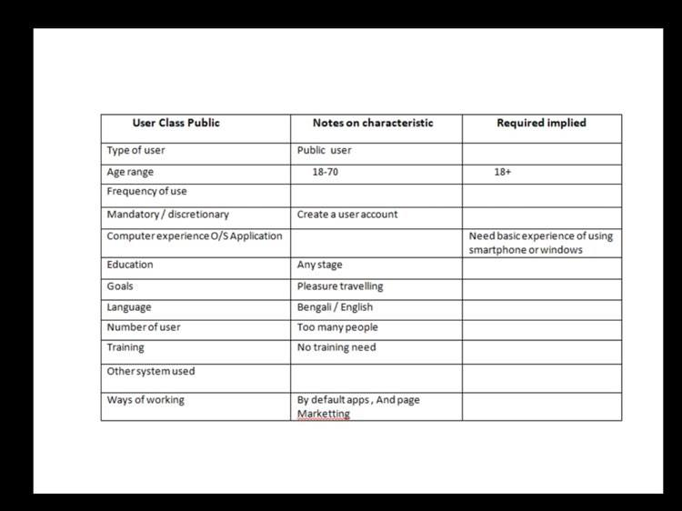(Tourist User Profile)

  
(Agent User Profile)  
  
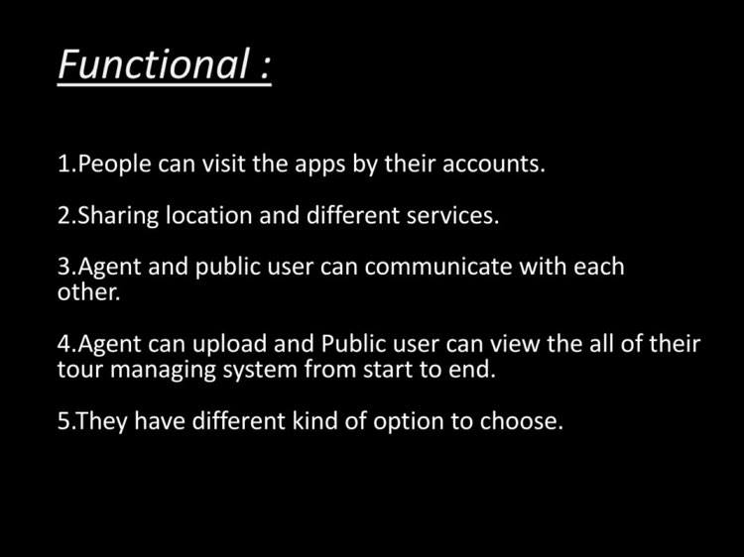  
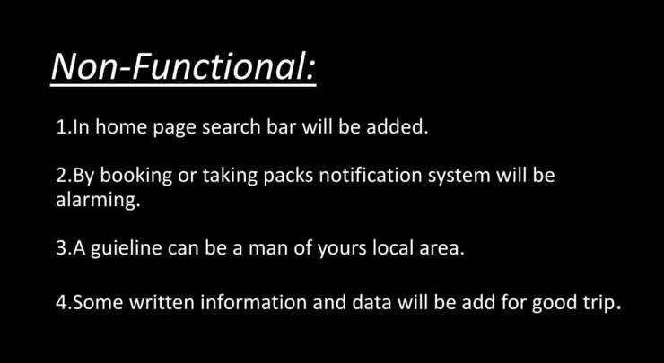

Use case diagram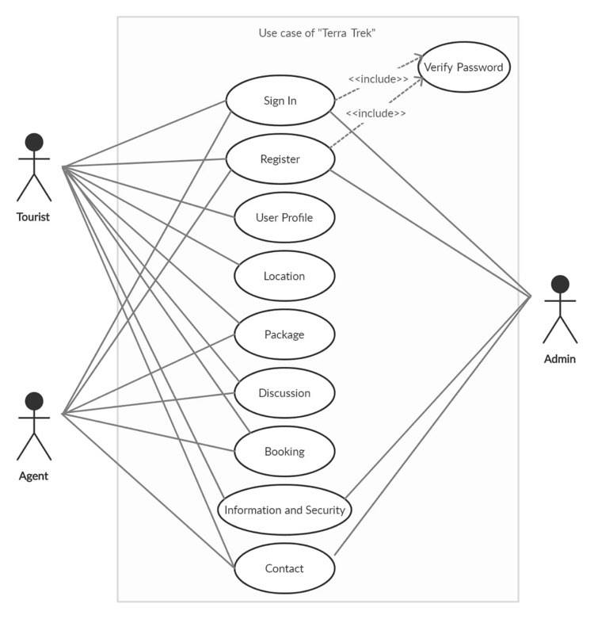  
  
  
  
  
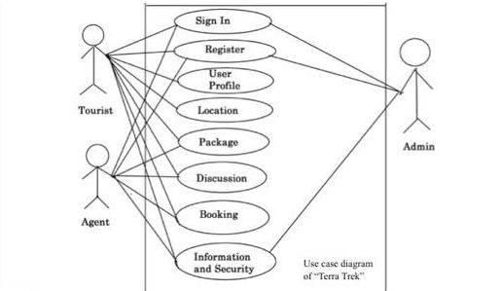

Storyboard  
  
Welcome page  
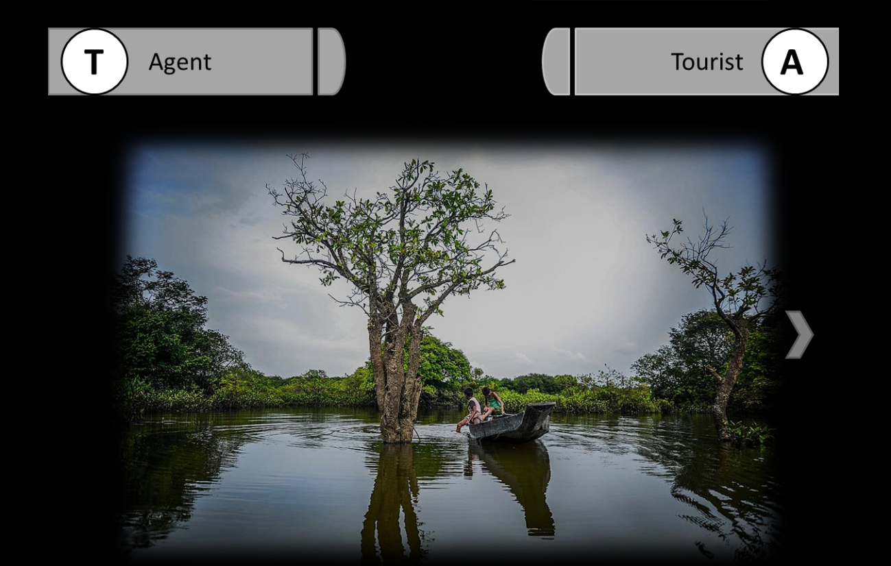  
  
Log in Menu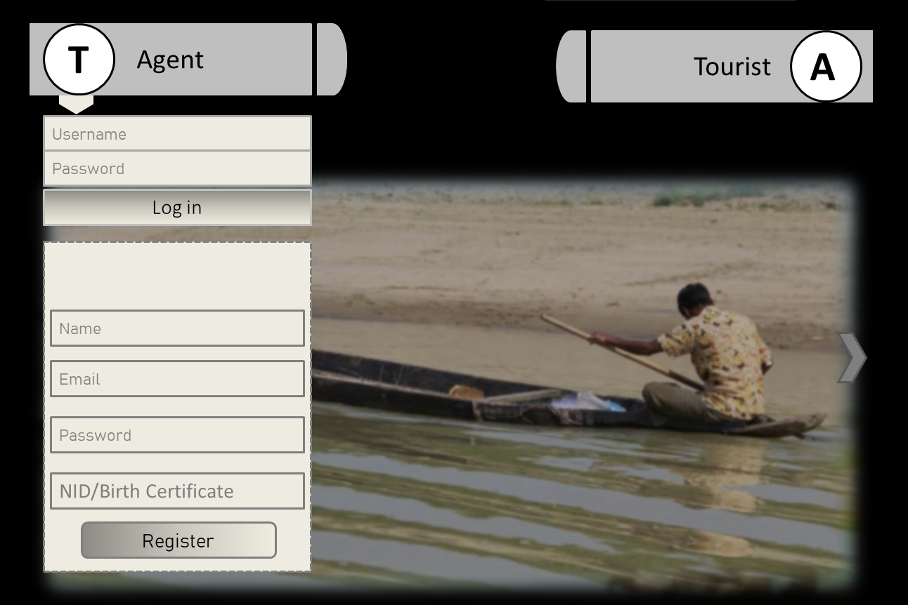  
Home Page  
  
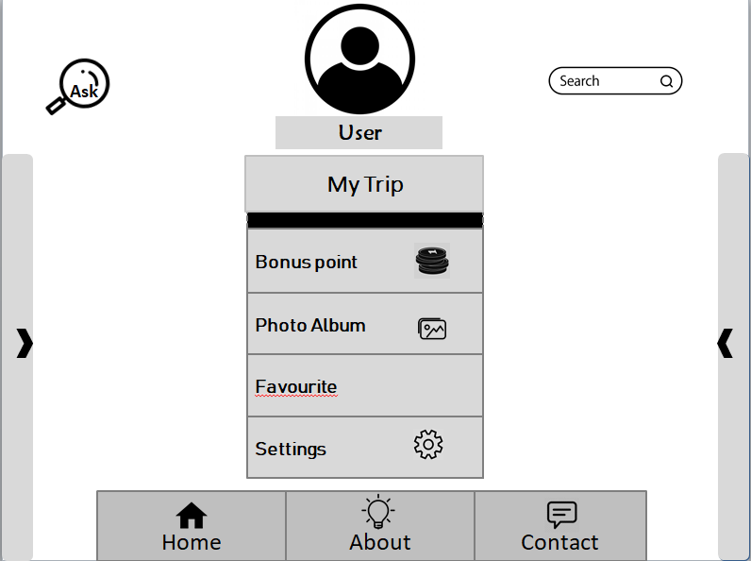  
  
Functional page  
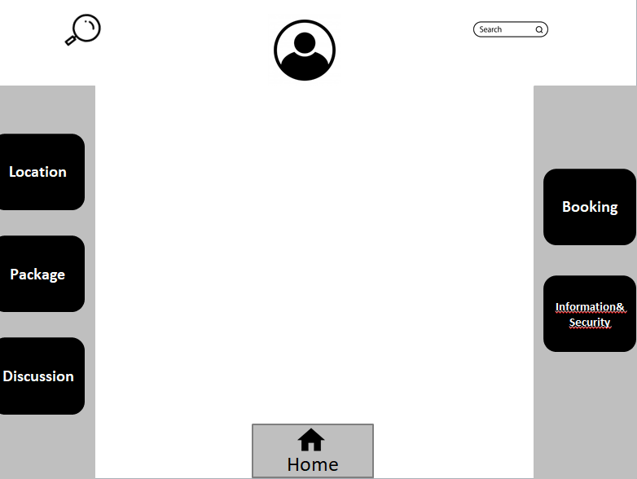

Location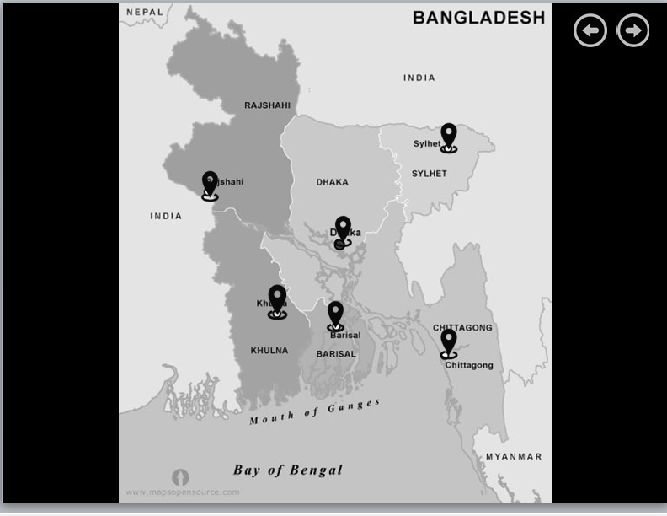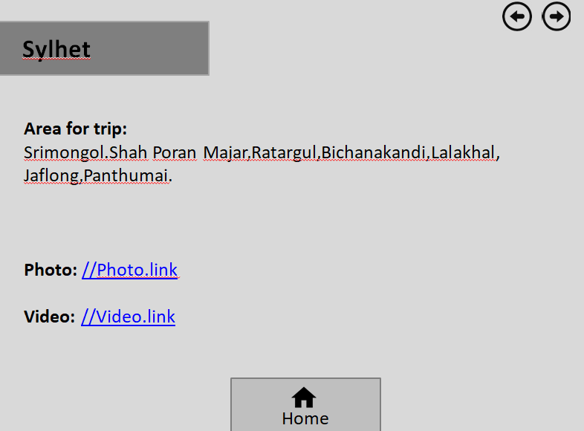

Pack  
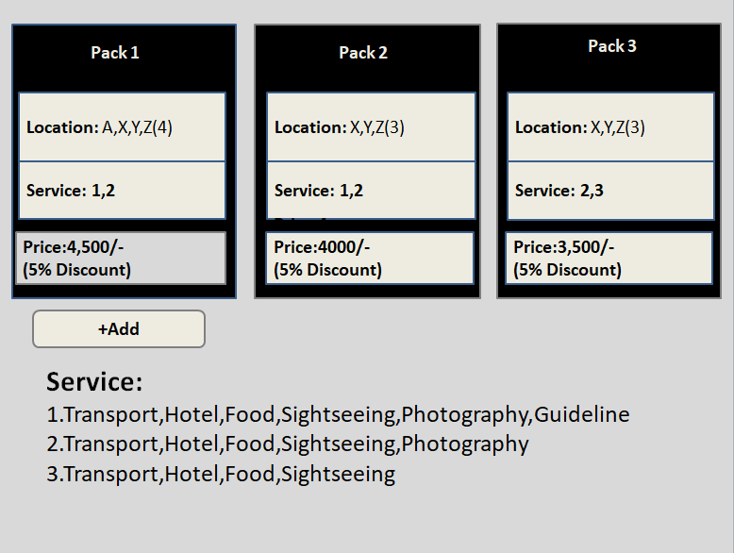

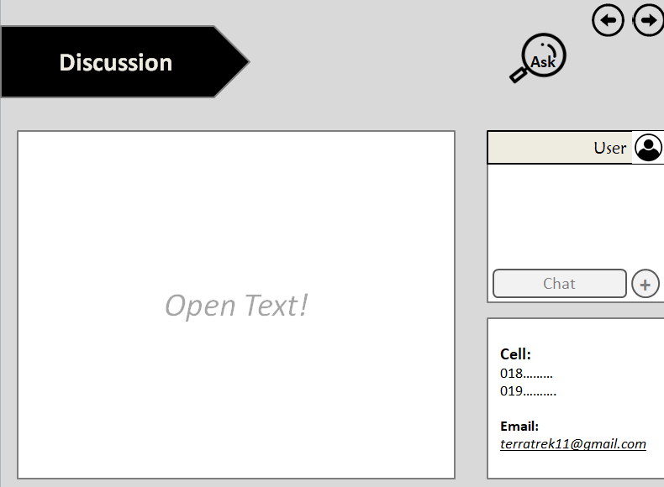

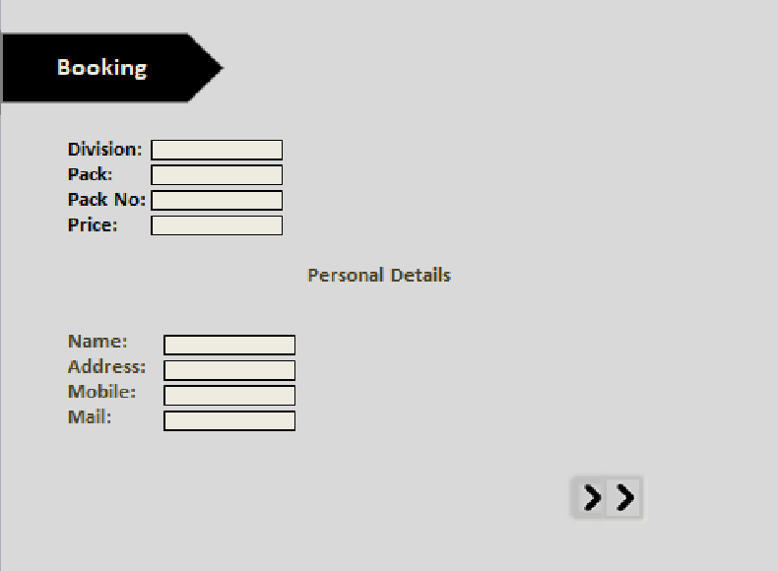

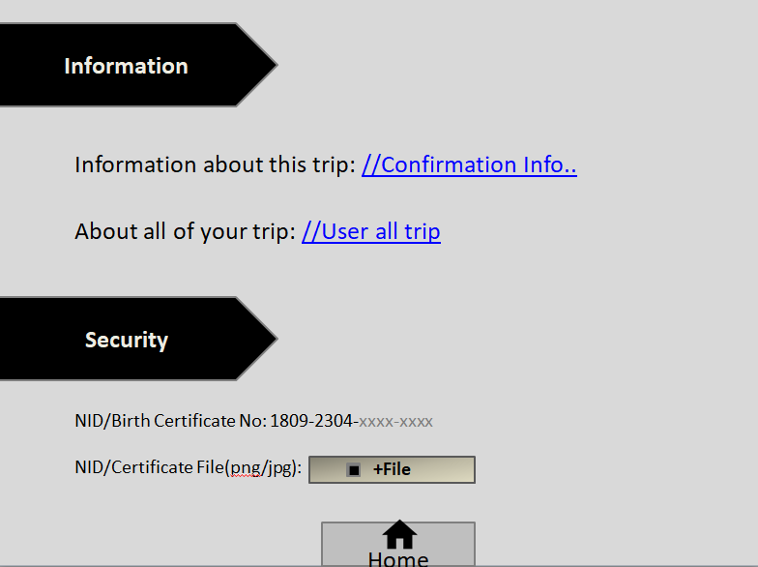

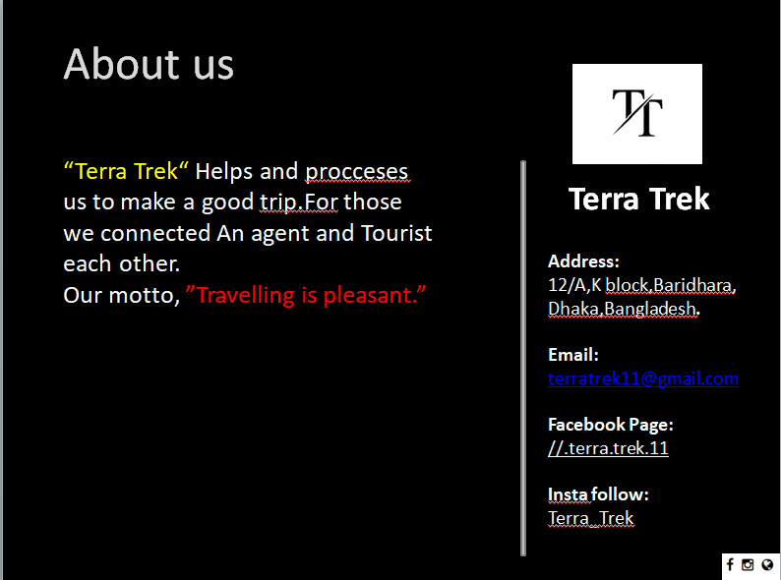

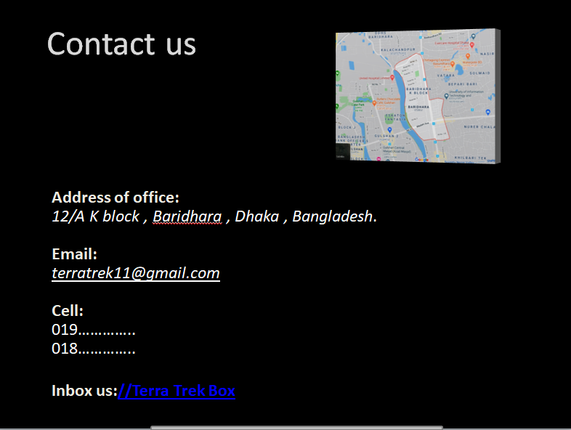

Er Diagram

